User Manual – Resilio File Sharing System

1. Introduction
The Resilio File Sharing System is a secure platform designed to streamline file management and sharing within your organization. This manual provides step-by-step guidance on how to navigate the system, register an account, and begin using its features.
1.2 Purpose of This Guide
This document covers the initial setup, including:
- User registration
- Account login
- Troubleshooting tips
2. Getting Started
2.1 Accessing the System
- Open your web browser and navigate to the local LAN IP like http://192.168.1.100:8888.
- The Welcome Screen will display two options:
  - Login (you need to register first because the first account is super admin)
  - Register (for super admin)
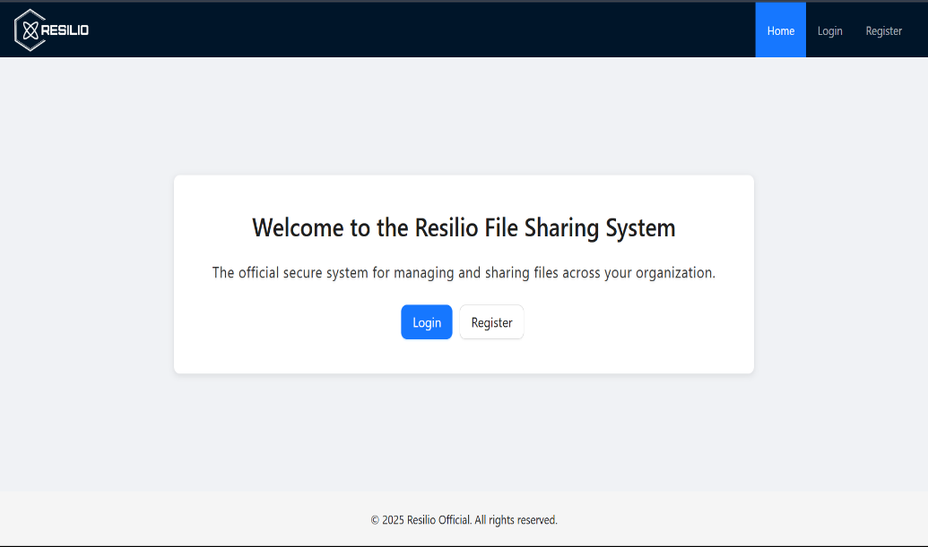

ADMIN
3. Admin Registration
3.1 How to Register
- Click the "Register" button on the Welcome Screen.
- Fill in the registration form:
  - 3.1.1 Username: Enter a unique username.
  - 3.1.2 Password: Create a strong password (use letters, numbers, and symbols).
  - 3.1.3 Confirm Password: Re-enter your password for verification.
- Click "Register" to complete the process.
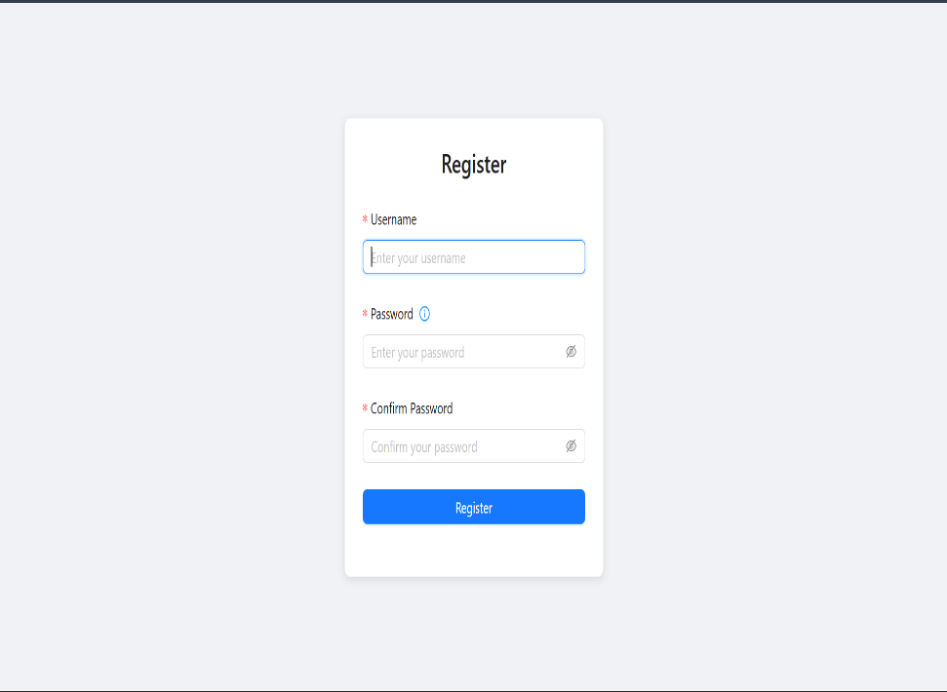

3.2 Registration Notes
- Usernames must be unique (no duplicates allowed).
- Passwords are case-sensitive (e.g., Password123 ≠ password123).
- The First Account is automatic super admin
4. Admin Login
4.1 How to Log In
- On the Welcome Screen, click "Login."
- Enter your credentials:
  - 4.1.1 Username: Your registered username (e.g., admin).
  - 4.1.2 Password: Your password (characters are hidden for security).
- Click "Log in" to access your account.
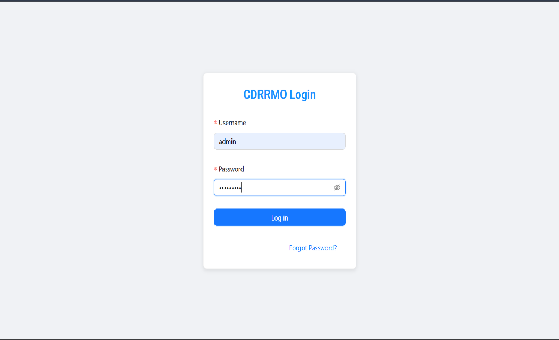

4.2 Troubleshooting Login Issues
- 4.2.1 Forgot Password?: Click the link to reset your password.
- 4.2.2 Account Locked?: Contact your system administrator.
4.3 Logout
- Admins & Users: Click "Logout" in the top-right corner to securely exit.
5.Administrator Function
5.1 Dashboard Navigation
- 5.1.1 Dashboard: System overview
- 5.1.2 User Management ( Adding, Edit and Remove User)
- 5.1.3 File Manager ( View, Edit, Move, Upload, Delete and Copy File)
- 5.1.4 Settings
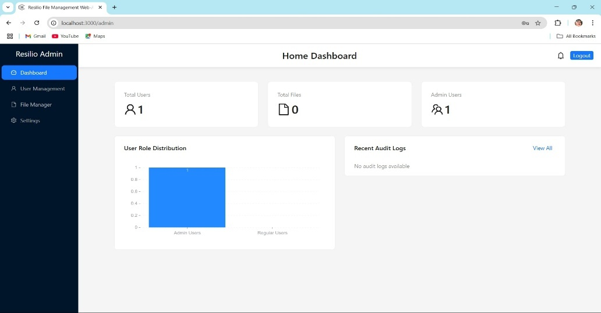

5.2 User Management
5.2.1 How to add User?
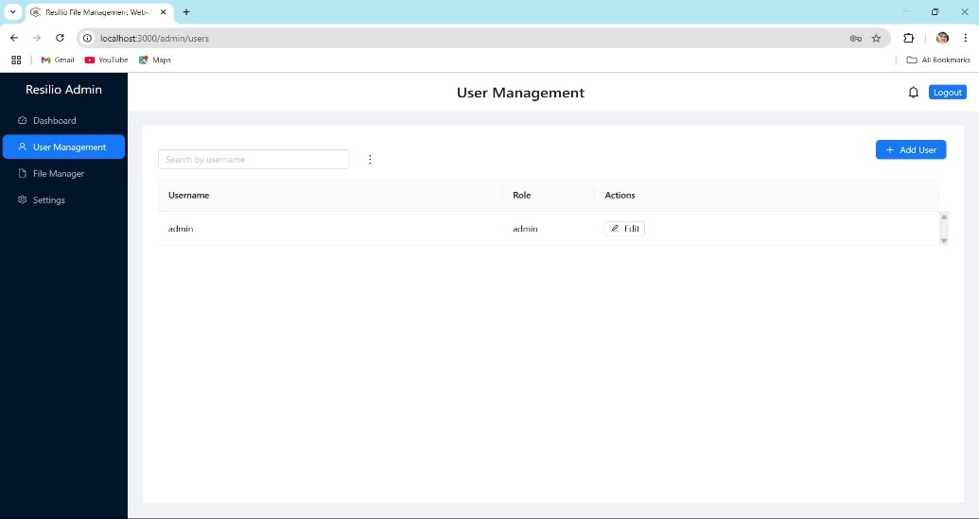

5.2.2 Adding Users
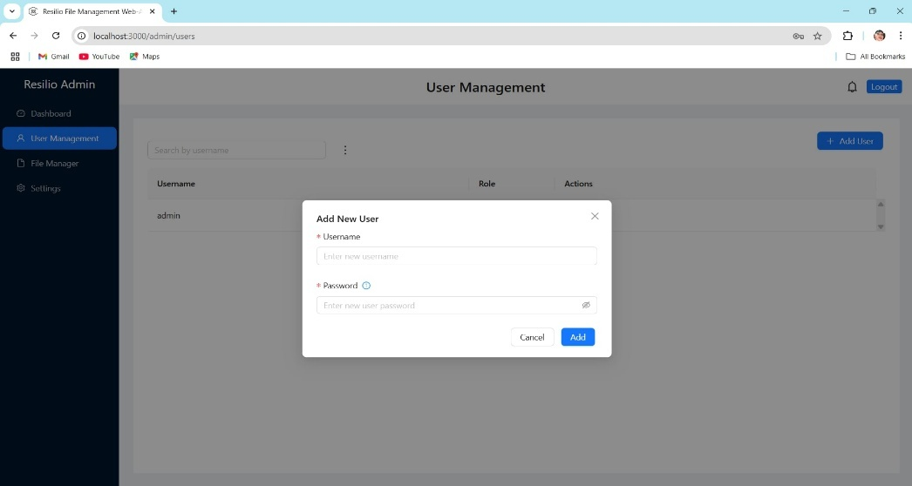
- Navigate to User Management → Add New User.

2.Enter:
  - Username
  - Password
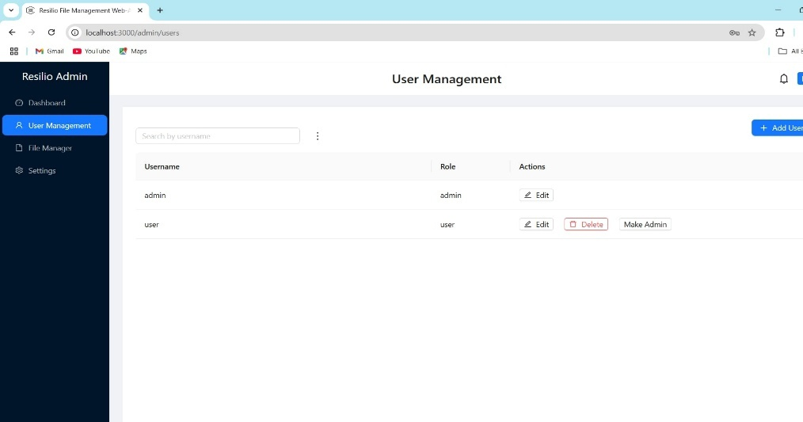
3.Click Add → User appears in the list

NOTE: If the user was created then you give it the username and password to the office member to log in in resilio system.
5.2.3 Editing Users
5.2.4 How to Edit
- Locate user in User List.
- Click make admin/ revoke admin (to change the role)
- Click Edit → Modify details (e.g., reset password,).
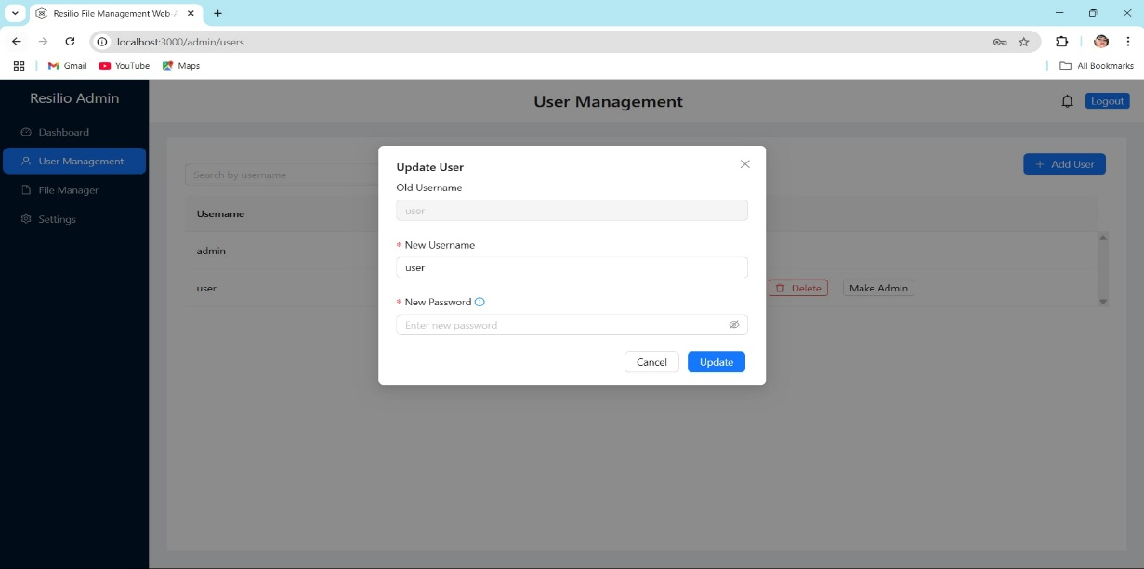
4.Click Update to save
6. File Management
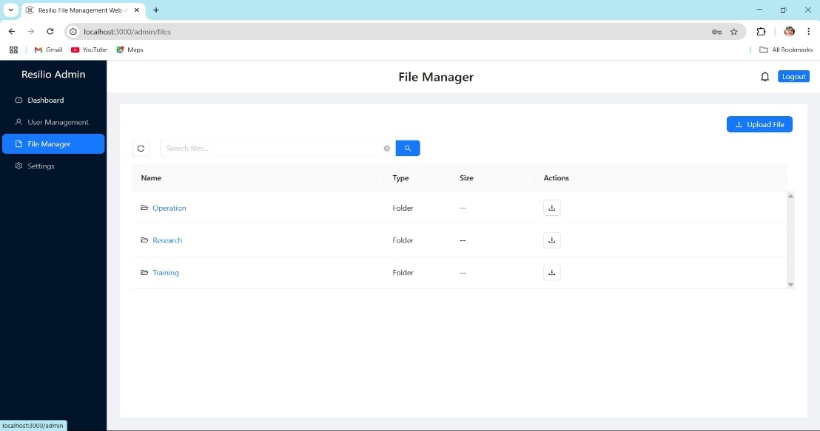
6.1 Folder Structure

Three default folders:
- Operation
- Training
- Research
Note: All file actions require a folder to be selected first.
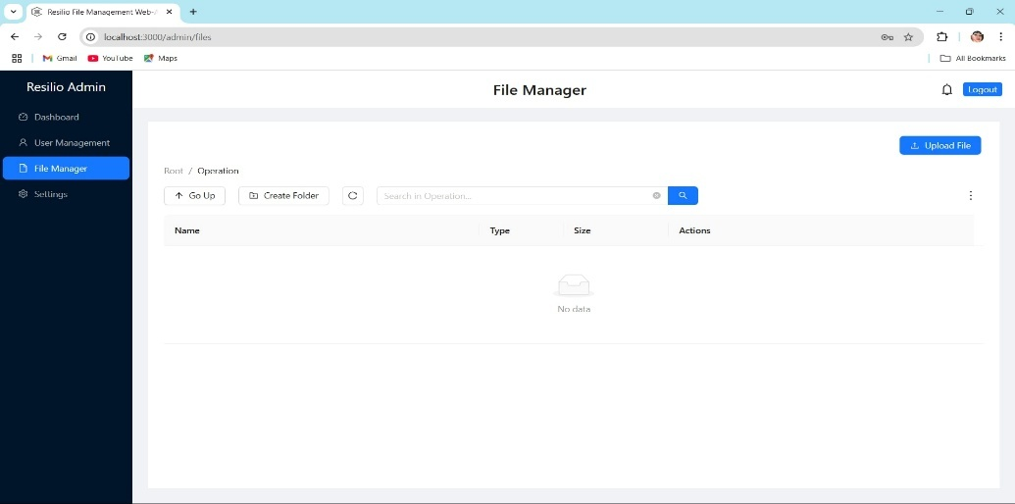
  - Uploading Files

6.2.1Select a folder → Click Upload File.
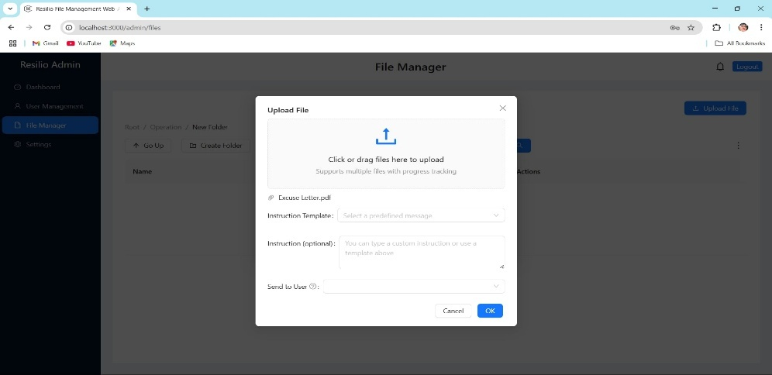
    - Choose files via:
  - Drag and drop into the window
  - Manual browse (file picker)
    - Assign to User (Appears after file Selection)
- Send To User : Select User from dropdown
- Instruction: Use a Prefined Template or type custom Instructions
    - Click Upload
- Progress bar shows completion
- System notifies assigned user

6.3 Viewing Files
Files are displayed with:
- Name (Click to preview)
- Type (e.g., PDF, DOCX)
- Size (MB/GB)
- Actions (Download, Share, Delete)
6.4 Navigating Folders
- Go Up: Returns to the parent folder.
- Search: Enter keywords to filter files (supports partial matches).
- Assignment Fiter: View Files assigned to specific user
7. Admin Settings
7.1 Accessing Settings
- Navigate to:
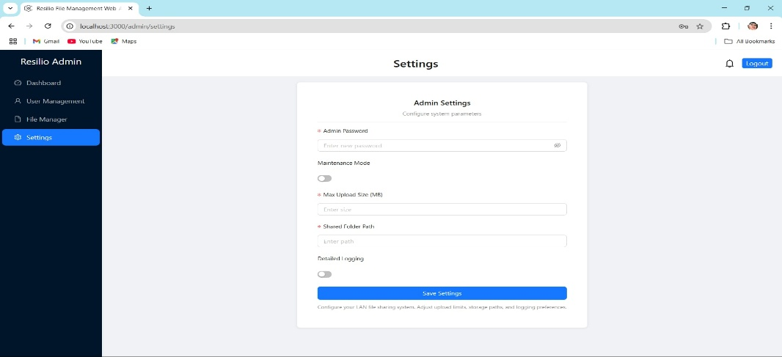
  - Resilio Admin → Settings (from sidebar)

7.2 Key Configuration Options
- Admin Password:
  - Enter new credentials for admin access.
- Maintenance Mode:
  - Toggle to disable user access during updates.
- Max Upload Size (MB):
  - Set file size limits (e.g., 500MB).
- Shared Folder Path:
  - Define default storage directory (e.g., C:\ResilioShared).
- Detailed Logging:
  - Enable for troubleshooting.
7.3 Saving Changes
- Click Save Settings to apply.
- System restarts services if path/limits are modified.
Warning: Changes to folder paths may require file migration
STANDARD USER OF SYSTEM
1. System Access
1.1 Accessing the System
- Open your web browser and navigate to the local LAN IP like http://192.168.1.100:8888.
Then you can see the log-in page of the system
1.2 Account Creation (Admin-Only)
1.Users cannot self-register
2.Contact your administrator to Create your username/password
1.3 Login Procedure
1.Enter admin-provided credentials:
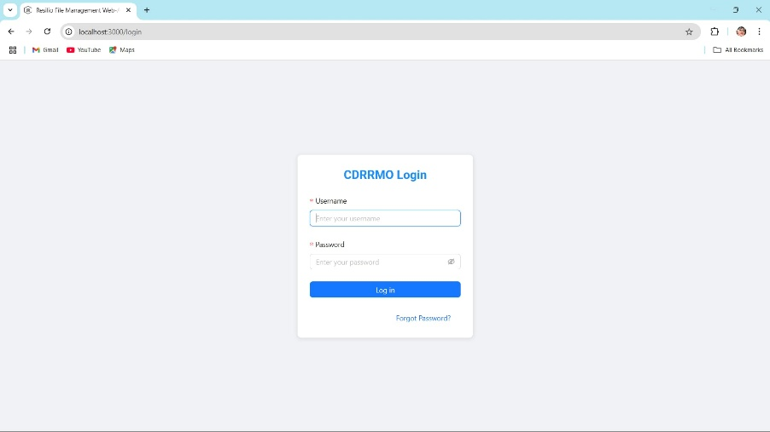
Note: Passwords are case-sensitive
2. Dashboard Overview
2.1 Navigation
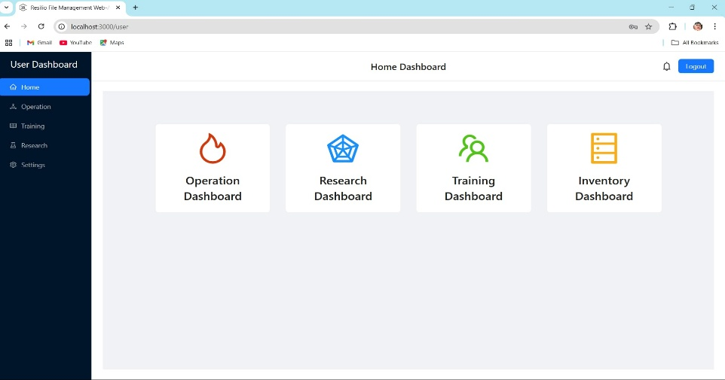

- Home: System announcements
- Operation/Training/Research: Department folders
- Settings: Personal preferences
3. File Management
3.1 Uploading Files
- Navigate to target folder (e.g., "Operation").
- Click Upload File or drag files:
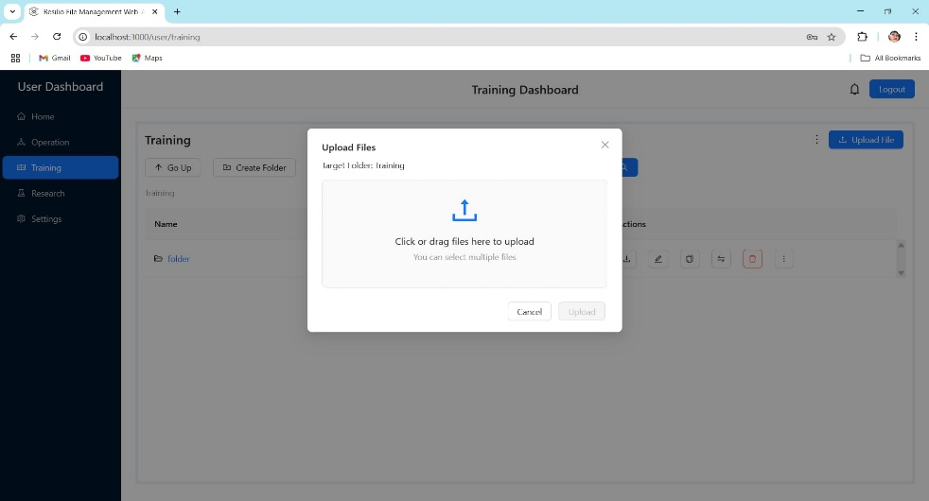
*Supports multi-file uploads with progress tracking.*

3.2 Folder Operation (selected folder )
- Create Subfolders:
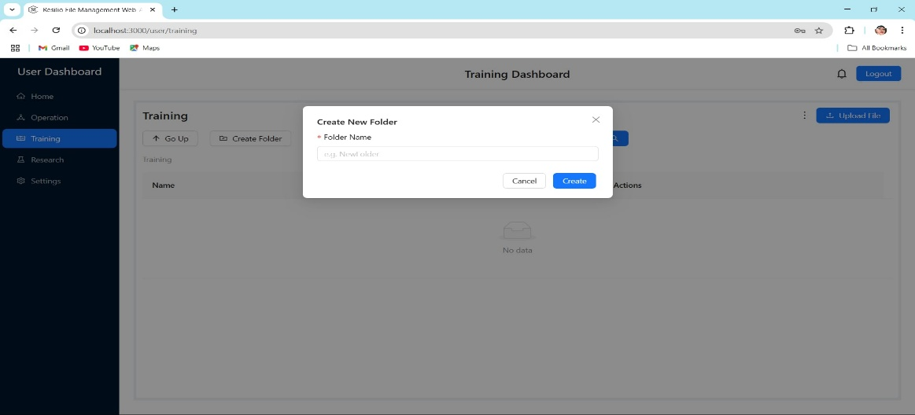
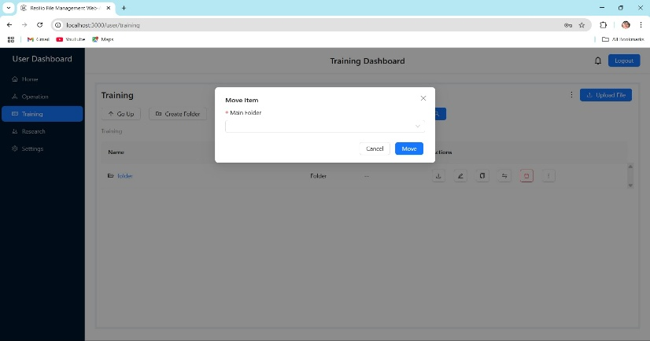
- Move and Copy Items: Duplicate files with modified names.
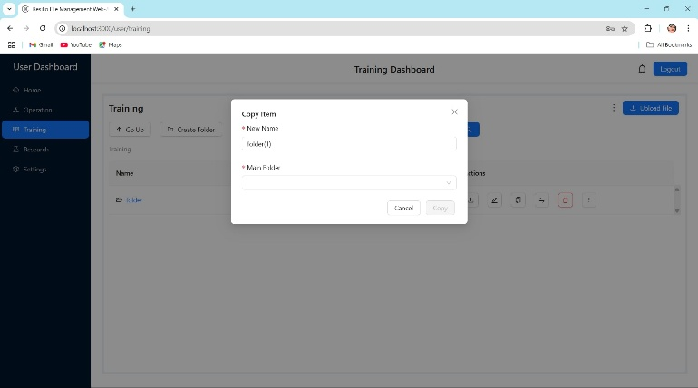
4. Task Collaboration
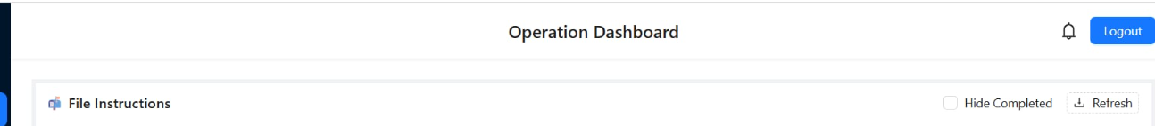
4.1 Viewing Admin Assignments
- Files shared by admins display:
  - 📝 Instructions (below filename)
  - ⏰ Deadlines (if specified)
  - ✔️ Completion checkbox
4.2 Marking Tasks Complete
- Locate assigned file in folder.
- Click checkbox to confirm completion
*Admins receive real-time status updates*.
5. Personal Settings
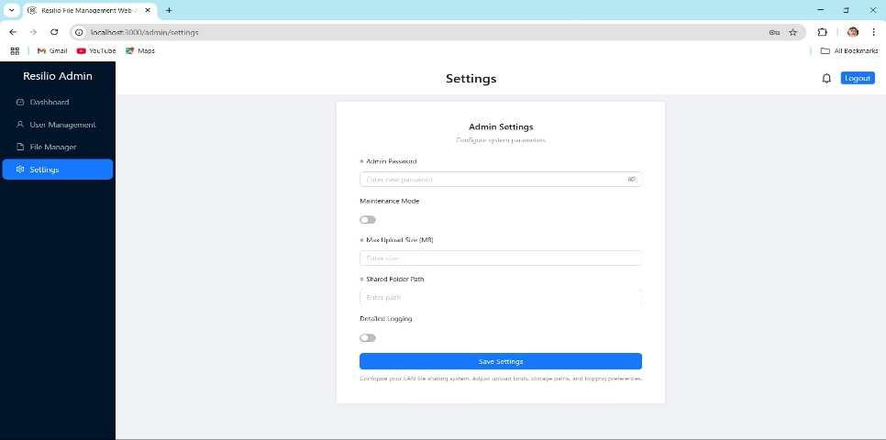
Settings are device-specific.
5.1 Customization Options
- Dark Mode: Reduce eye strain
- Notifications: Enable/disable alerts
6. Log Out
6.1 How to Log out?
Click the log-out button in the right top.

